**44. Template Information**

--- cat deployment.yml

apiVersion: apps/v1

kind: Deployment

metadata:

  name: {{ include "firstchart.fullname" . }}

  labels:

    {{- include "firstchart.labels" . | nindent 4 }}

spec:

  {{- if not .Values.autoscaling.enabled }}

  replicas: {{ .Values.replicaCount }}

  {{- end }}

  selector:

    matchLabels:

      {{- include "firstchart.selectorLabels" . | nindent 6 }}

  template:

    metadata:

      {{- with .Values.podAnnotations }}

      annotations:

        {{- toYaml . | nindent 8 }}

      {{- end }}

      labels:

        {{- include "firstchart.selectorLabels" . | nindent 8 }}

    spec:

      {{- with .Values.imagePullSecrets }}

      imagePullSecrets:

        {{- toYaml . | nindent 8 }}

      {{- end }}

      serviceAccountName: {{ include "firstchart.serviceAccountName" . }}

      securityContext:

        {{- toYaml .Values.podSecurityContext | nindent 8 }}

      containers:

        - name: {{ .Chart.Name }}

          securityContext:

            {{- toYaml .Values.securityContext | nindent 12 }}

          image: "{{ .Values.image.repository }}:{{ .Values.image.tag | default .Chart.AppVersion }}"

          imagePullPolicy: {{ .Values.image.pullPolicy }}

          ports:

            - name: http

              containerPort: 80

              protocol: TCP

          livenessProbe:

            httpGet:

              path: /

              port: http

          readinessProbe:

            httpGet:

              path: /

              port: http

          resources:

            {{- toYaml .Values.resources | nindent 12 }}

      {{- with .Values.nodeSelector }}

      nodeSelector:

        {{- toYaml . | nindent 8 }}

      {{- end }}

      {{- with .Values.affinity }}

      affinity:

        {{- toYaml . | nindent 8 }}

      {{- end }}

      {{- with .Values.tolerations }}

      tolerations:

        {{- toYaml . | nindent 8 }}

      {{- end }}

--- When Helm renders a template, it passes all the information for the template as a single object represented by DOT.

--- If you open the deployment.yml or hpa.yml , ingress.yml. you will find this dot at the beginning and then values(**.values**).

--- So, this dot represents all the information that a template can use, and it has sub objects like values. The sub object values contain all the information from values.yml.

**Create a custom value in values.yml and access it from deployment.yml files**

--- note – I will create custom value in values.yml file.

--- vi values.yml

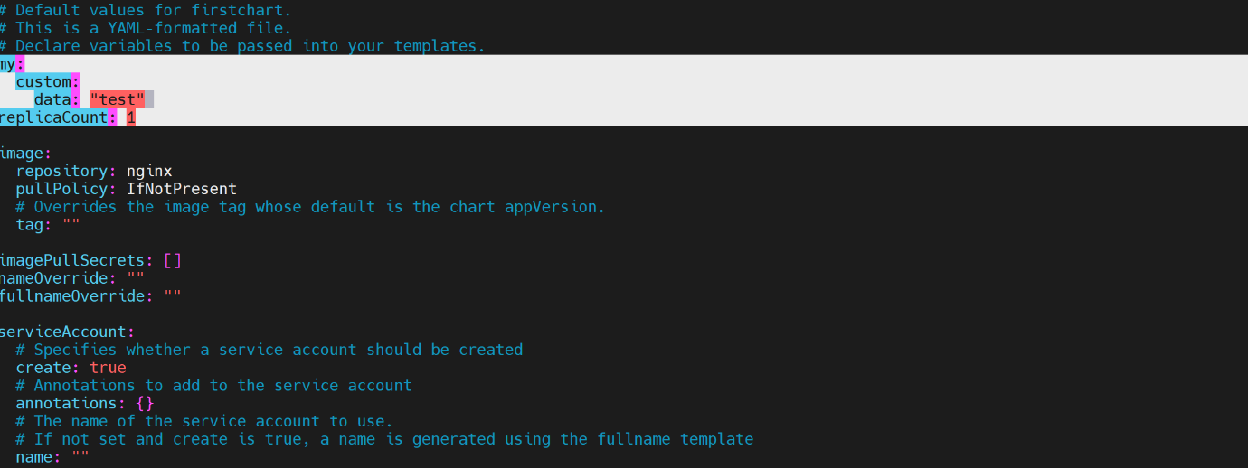

--- **note** – I have added custom data into values.yml file.

**Access custom date form deployment.yml file**

--- vi deployment.yml

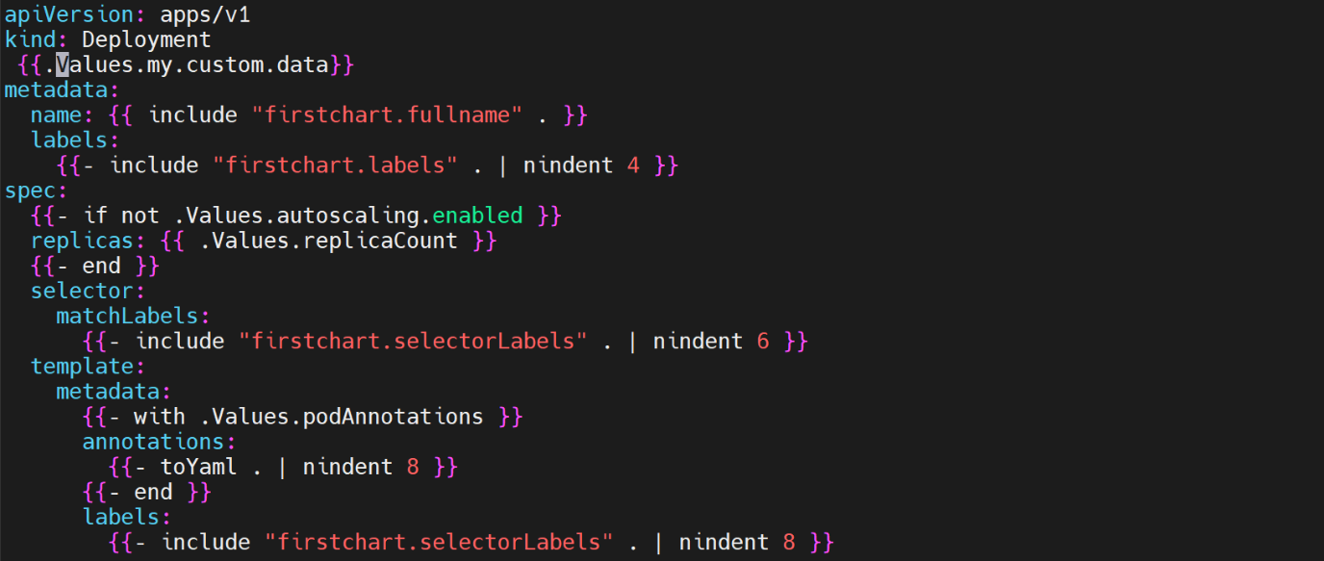

--- **note** – this is how we can access custom data form values.yml.

# Check the template of chart to see it is working or not.

--- helm template firstchart

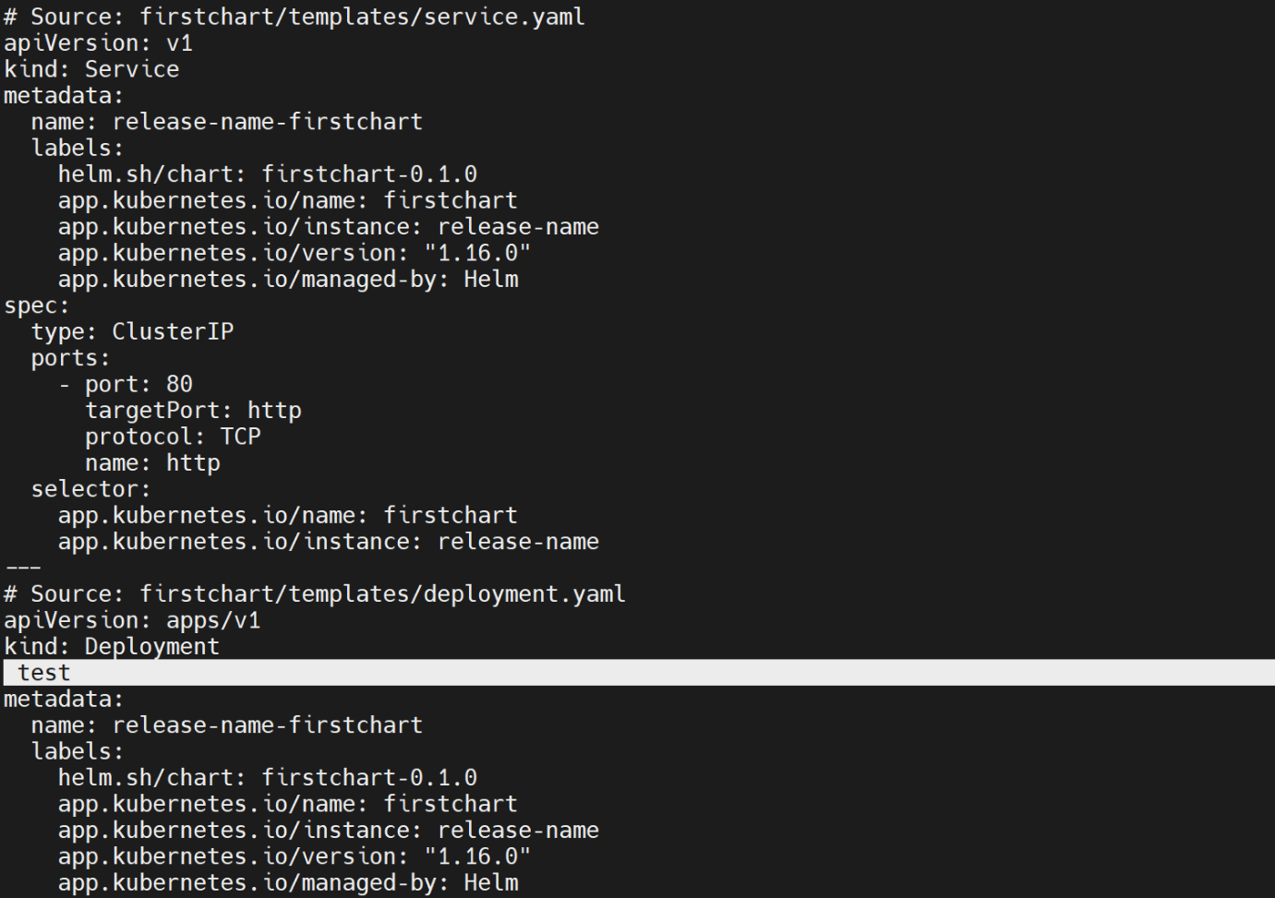

--- **note** – now we are successfully access the custom values form the values.yml

**Access the chart.yml information form template folder files**

--- **note** – I will access Chart.yml files values from deployment.yml.

**# List structure of our folder**

--- tree

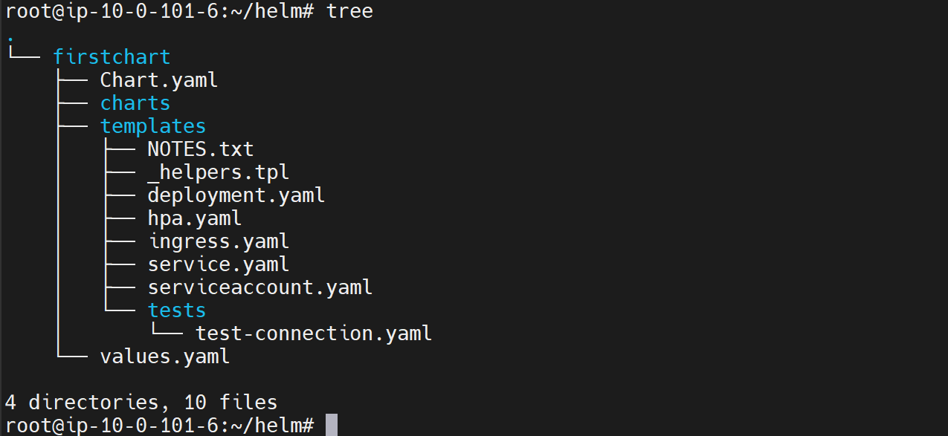

--- cat Charts.yml

apiVersion: v2

name: firstchart

description: A Helm chart for Kubernetes

icon: https://stacksimplify.live/project.jpg

keywords:

     - db project

     - healthcare

home: https://stacksimplify.live

sources:

     -  https://stacksimplify.live/project.jpg

     -  https://stacksimplify.live/project.jpg

maintainers:

     - name: prabhu

       email: test@gmail.com

     - name: jhon

       email: jshon@gmail.com

# A chart can be either an 'application' or a 'library' chart.

#

# Application charts are a collection of templates that can be packaged into versioned archives

# to be deployed.

#

# Library charts provide useful utilities or functions for the chart developer. They're included as

# a dependency of application charts to inject those utilities and functions into the rendering

# pipeline. Library charts do not define any templates and therefore cannot be deployed.

type: application

# This is the chart version. This version number should be incremented each time you make changes

# to the chart and its templates, including the app version.

# Versions are expected to follow Semantic Versioning (https://semver.org/)

version: 0.1.0

# This is the version number of the application being deployed. This version number should be

# incremented each time you make changes to the application. Versions are not expected to

# follow Semantic Versioning. They should reflect the version the application is using.

# It is recommended to use it with quotes.

appVersion: "1.16.0"

--- deployment.yml

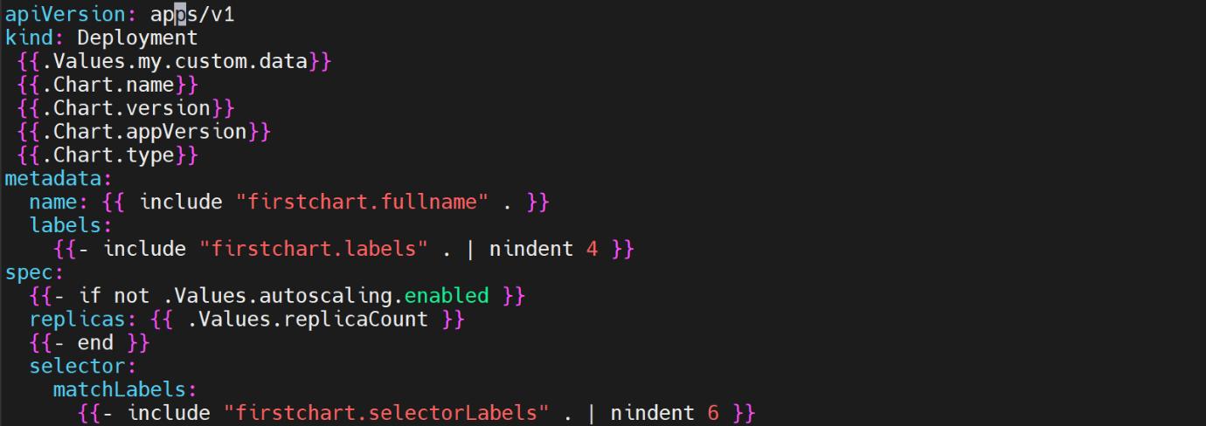

**# Output the template of firstchart.**

--- helm template firstchart

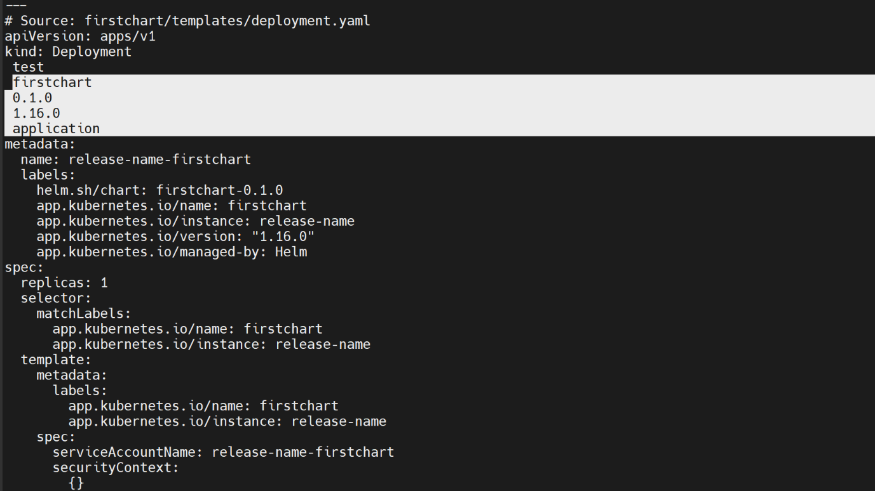

--- **note** – now I can access the values from Chart.yml file.

**Access the release information**

--- **note** – I will access releasee information form deployment.yml

--- cat deployment.yml

apiVersion: apps/v1

kind: Deployment

 {{.Values.my.custom.data}}

 {{.Chart.Name}}

 {{.Chart.Version}}

 {{.Chart.AppVersion}}

 {{.Chart.Type}}

 {{.Release.Name}}

 {{.Release.Namespace}}

 {{.Release.IsInstall}}

 {{.Release.IsUpgrade}}

metadata:

  name: {{ include "firstchart.fullname" . }}

  labels:

    {{- include "firstchart.labels" . | nindent 4 }}

spec:

  {{- if not .Values.autoscaling.enabled }}

  replicas: {{ .Values.replicaCount }}

  {{- end }}

  selector:

    matchLabels:

      {{- include "firstchart.selectorLabels" . | nindent 6 }}

**# Check the output firstchart template**

--- helm template firstchart

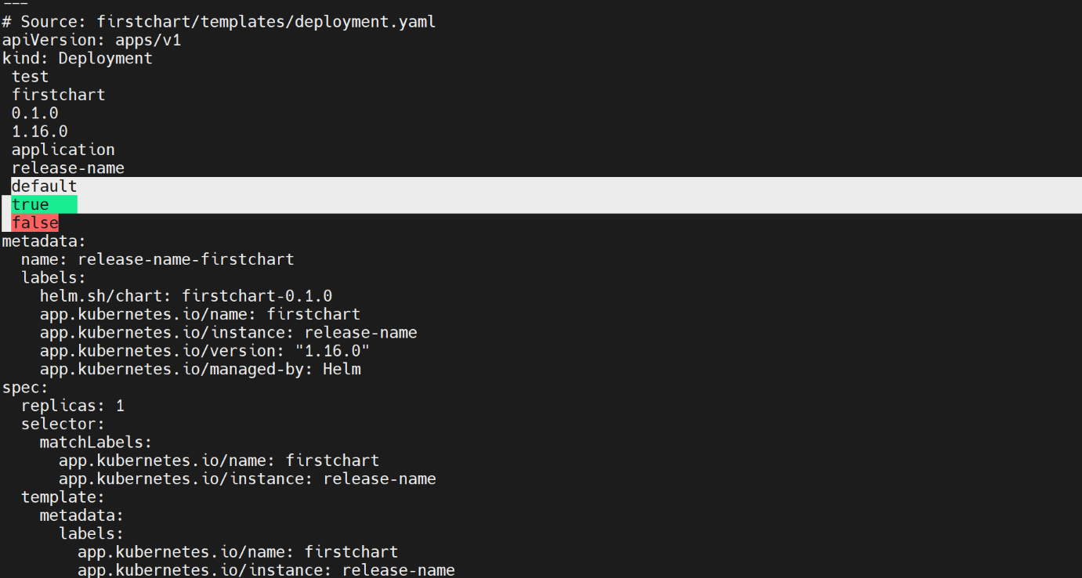

**Access the template information**

--- **note** – access the template information.

--- cat deployment.yml

apiVersion: apps/v1

kind: Deployment

 {{.Values.my.custom.data}}

 {{.Chart.Name}}

 {{.Chart.Version}}

 {{.Chart.AppVersion}}

 {{.Chart.Type}}

 {{.Release.Name}}

 {{.Release.Namespace}}

 {{.Release.IsInstall}}

 {{.Release.IsUpgrade}}

 {{.Template.Name}}

 {{.Template.BasePath}}

metadata:

  name: {{ include "firstchart.fullname" . }}

  labels:

    {{- include "firstchart.labels" . | nindent 4 }}

spec:

  {{- if not .Values.autoscaling.enabled }}

  replicas: {{ .Values.replicaCount }}

  {{- end }}

**# Check the output firstchart template**

--- helm template firstchart

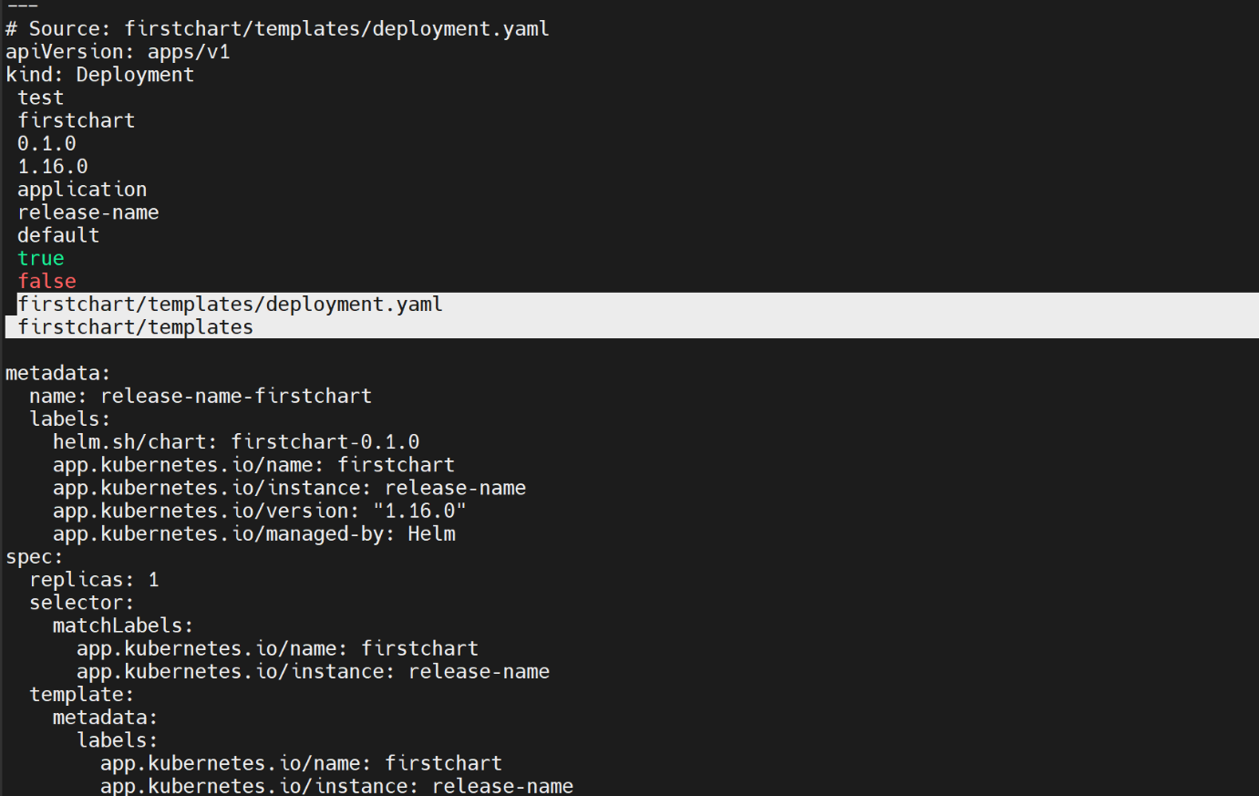

--- important - Dot represents an object that has the entire information that can be accessed in any of the templates. .Values is a sub object that points to values.yml.

--- Chart points to Chart.yml and .Release will give you the release information dynamically when and installation or upgrades happening.

--- Template will give the information about the current template that is being rendered